SQL Assignment – Student Database
1. Select the first name, last name, and city of all students.
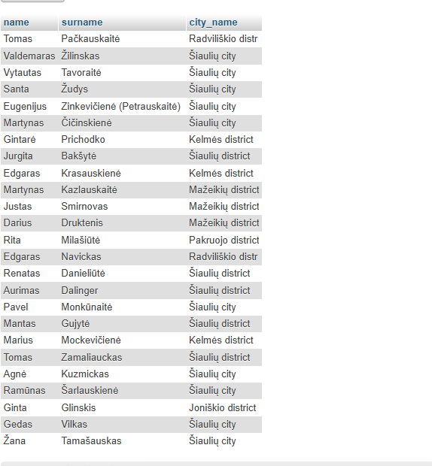
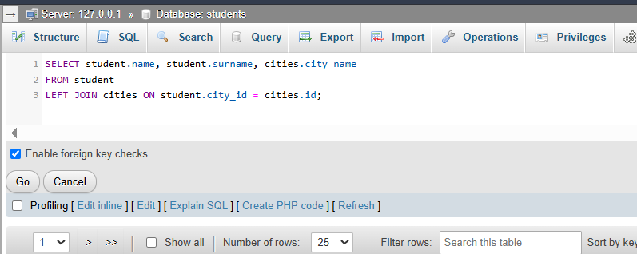

2. Select the first name, last name, and group of students, excluding groups that start with KTn.

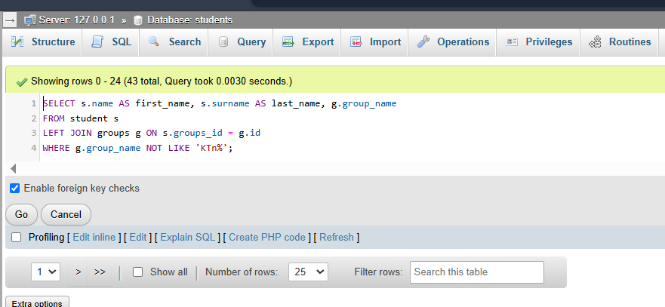
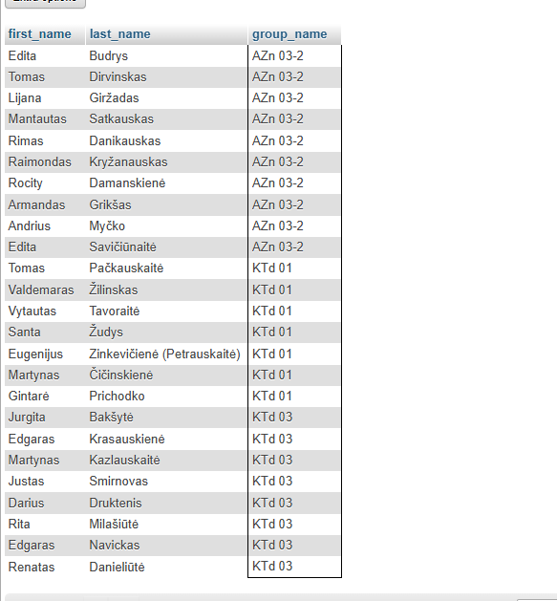

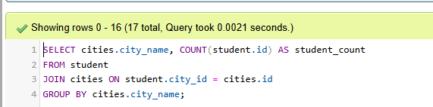
3. Calculate how many students live in each city.

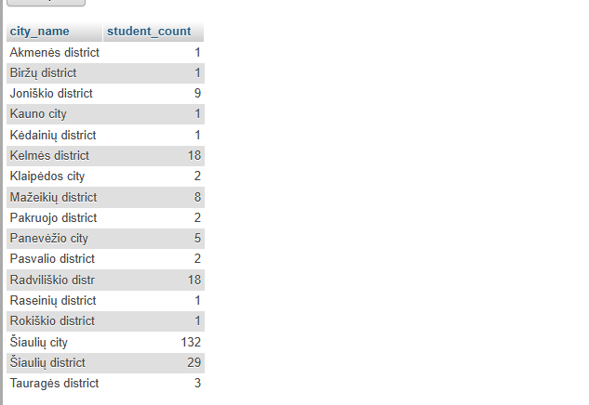

4. Count how many students in each group have Active status.

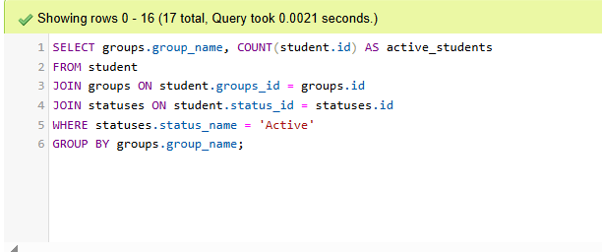
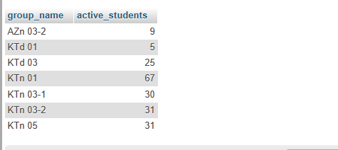

5. Display the three groups with the highest number of students.
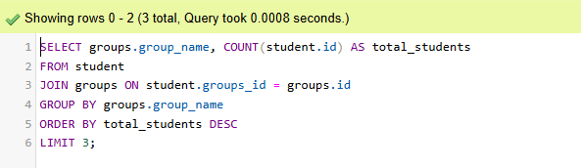
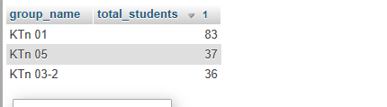
6. Find cities where multiple students have the same first name. Display the city, student name, and number of students with that name.
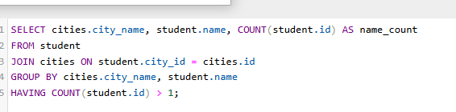
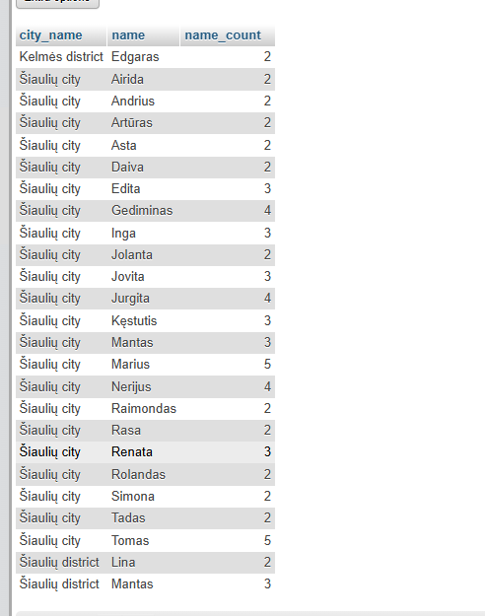

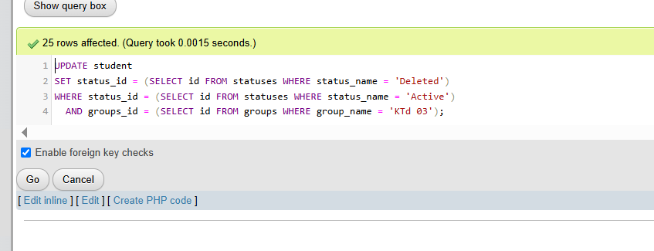
7. Change the status of students in group KTd 03 from Active to Deleted.
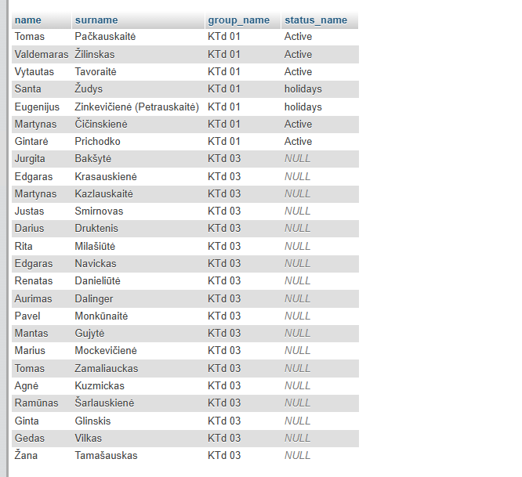

8. Calculate the average number of students living in cities and districts using UNION.
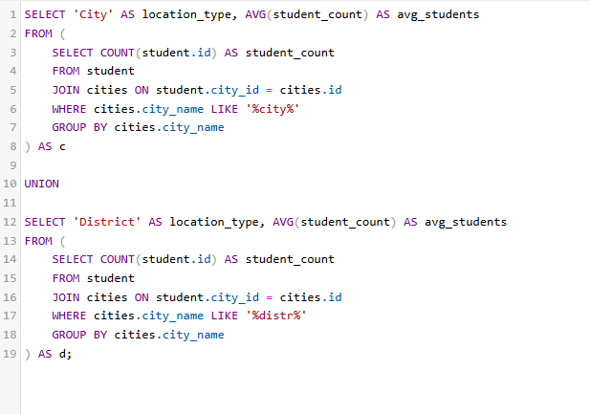
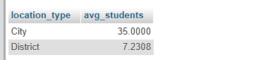

9. Delete all students whose status is Holidays.
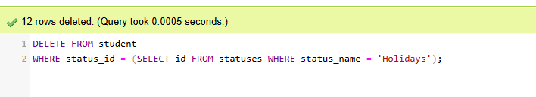
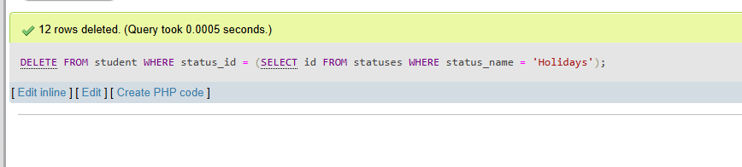

10.
a) Remove Šiauliai city and district information from the student table.
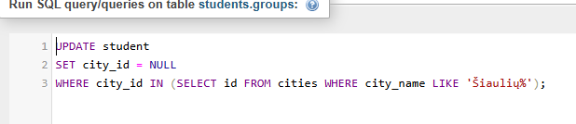
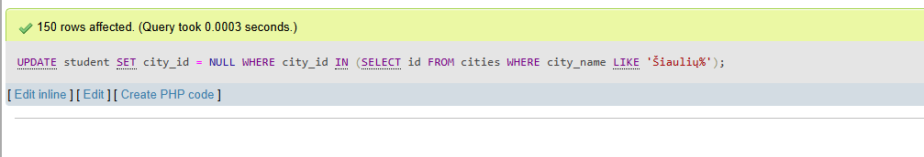

b) Display all students according to Task 1, sorting students without a city at the bottom of the list.


